CAPSTON PROJECT

CUSTOMER SATISFACTION

Name : E.Sivanarayanan

Reg No : 950921105006

Dept : Electrical and Electronic Engineering

College : Holy Cross Engineering College

\

**Analyzing Customer**

**Satisfaction Data: Insights and Strategies for Enhancing**

**Customer Experience**

Welcome to the presentation on Analyzing

**Introduction** Customer Satisfaction Datastrategies for enhancing customer. We will explore experience through data analysis and insights.



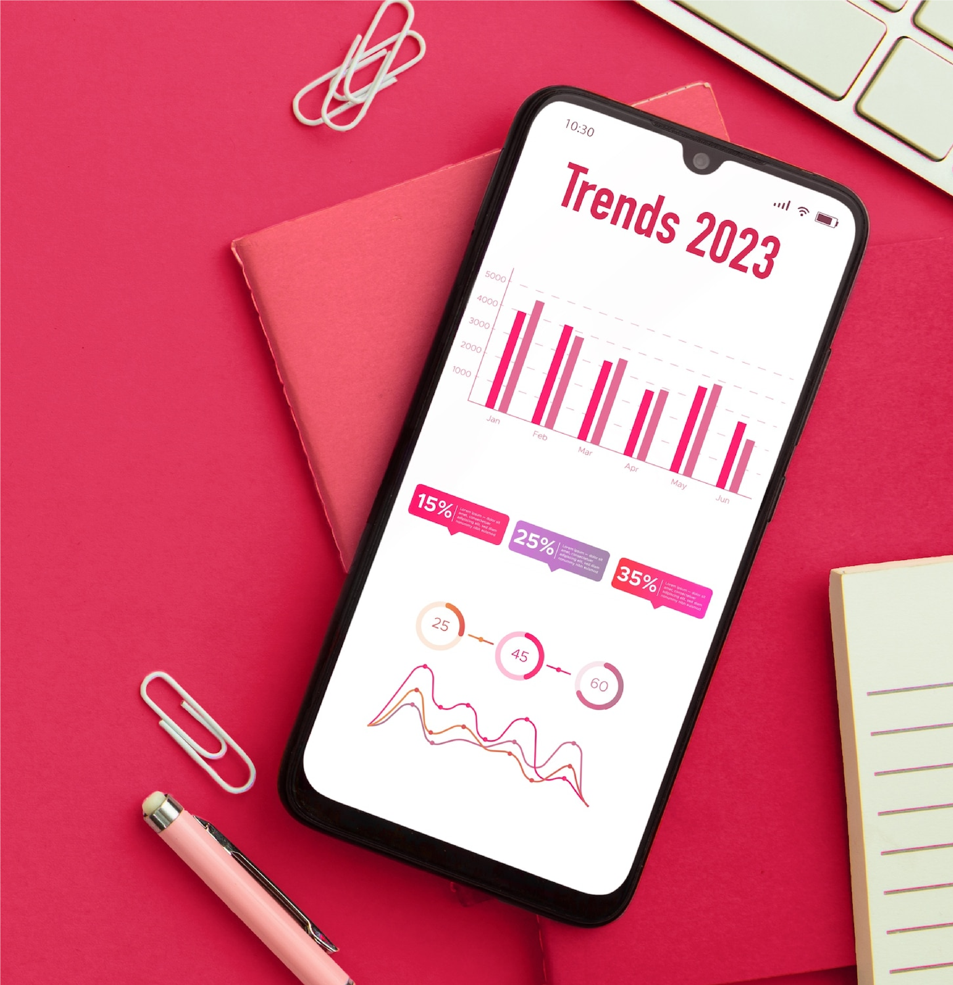

Analyzing

**customer feedback**

is

crucial for identifying pain points

and areas of improvement. Utilize

data to uncover patterns and

trends in

customer satisfaction

.

**Understanding Customer Feedback**



Key metrics such as

Net

Promoter Score (NPS)

and

Customer Satisfaction Score

(

CSAT

)

provide valuable insights

into customer sentiment. These

metrics aid in measuring and

monitoring

customer satisfaction

levels.

**Key Metrics for Customer**

**Satisfaction**

Implement strategies to enhance customer

**Enhancing Customer Experience** experience based on data-driven insights. Personalization, proactive support, and continuous feedback loops are essential for improving customer satisfaction.



**Actionable Insights from Data Analysis**

Data analysis uncovers actionable insights that drive informed decision-making. Leverage insights to prioritize improvements and initiatives that directly impact customer satisfaction.

**Conclusion**

In conclusion, leveraging customer satisfaction data is pivotal for enhancing customer experience. By analyzing insights and implementing strategies, organizations can foster longterm customer loyalty and satisfaction.

**Thank YOU..**